**Invest in Reykjavik**

# Frontpage

Reykjavik is a young, vibrant city inhabited by an educated, highly skilled population. It is the capital of Iceland; a Nordic country with an excellent infrastructure and a high quality of life. The city is surrounded by nature, where within an hour’s drive you can experience glaciers, waterfalls, lava canyons and other geological wonders. Iceland is located half way between North-America and Europe and is renowned for its approach towards sustainability, where 99% of all electricity in Iceland is generated from green, renewable energy.

# About us

**City of Reykjavik Department of Economic Development**

The City of Reykjavik’s Department of Economic Development promotes Reykjavik as a business location and assists local and international companies considering locating or expanding in Reykjavik to reach their business objectives, as well as develop new and interesting economic areas in the city of Reykjavik.

The department is also focused on strengthening the competitiveness of the city of Reykjavik. We work closely with key partners in the Reykjavik area to ensure our customers quickly receive relevant, quality information regarding their interests.

[Promote Iceland](http://www.islandsstofa.is/en) – Iceland’s investment and export promotion agency.

[Innovation Center Iceland](http://www.nmi.is/english) – Iceland’s innovation R&D and business support institute

[Visit Reykjavik](http://www.visitreykjavik.is) – an official point of contact for tourism, marketing, information and events in Reykjavik

The department can be contacted at [invest@reykjavik.is](mailto:invest@reykjavik.is)

# Reykjavik Investment Profile

Reykjavik is recognized as a world leader in the fields of geothermal and seafood industries. Other strong industries in the city are the biotech, medical equipment, tourism, IT, and the creative industries. Iceland has a thriving startup business community encompassing all of the aforementioned industries. The IT startup scene, mostly located in the city center, is growing very rapidly largely due to access to inexpensive renewable energy and the creative ingenuity of the population. Several international companies have workstations in Reykjavik, taking advantage of the country’s strong entrepreneurial culture and cost-competitive environment.

## Reykjavik Capital Area

The Reykjavik Capital Area stretches from Hvalfjordur in the north to Hafnarfjordur in the south. It consists of: Reykjavik (pop. 120,000), Kopavogur (32,000), Seltjarnarnes (4,300), Gardabaer (13,800), Hafnarfjordur (27,000), Mosfellsbaer (9,000), and Kjosahreppur (200). The total population of the capital area is over 200,000, which is nearly 65% of the Icelandic population. The greater capital area - defined as the area within a 45-minute catchment zone from Reykjavik city center - has an additional 40,000 inhabitants which amounts to 75% of the country’s population.

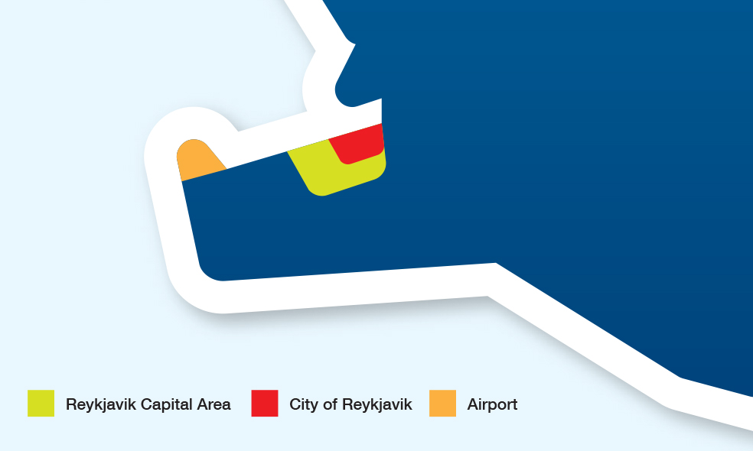

Reykjavik has experienced steady population growth, while other parts of Iceland have remained unchanged or decreased.

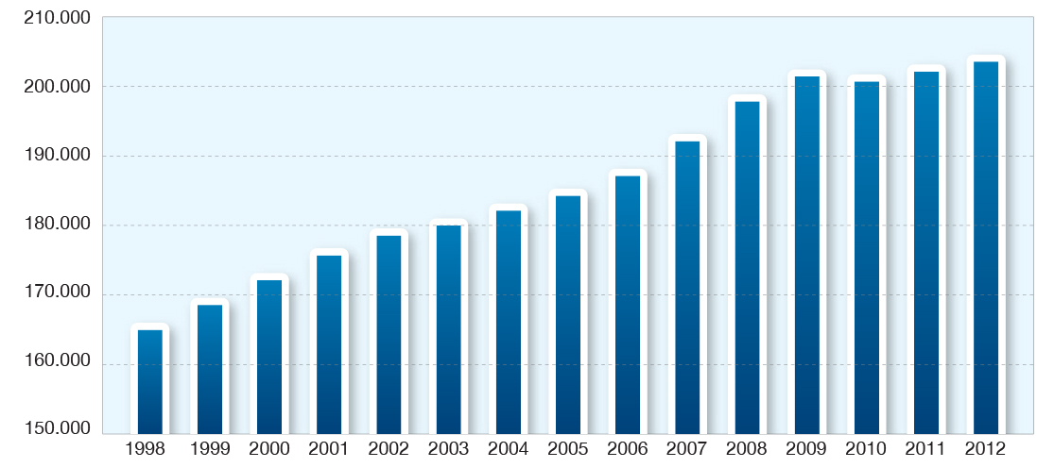

Population of the Reykjavik capital area 1998-2012

All of Iceland’s largest companies outside of aluminum and seafood are located in Reykjavik, as are the majority of Iceland’s main cultural, educational, and research institutions.

**Reykjavik city center**

The city center of Reykjavik is the location of parliament, most ministries, governmental organizations, and the City Hall. It’s also the location of some key cultural institutions and the two main universities of Iceland. The city center also has an impressive selection of restaurants, cafés and galleries along with an eclectic mix of retailing options. The city center is also the key location of the Reykjavik startup scene.

The city center stretches from Hlemmur in the east to the old harbor in the west. Connecting these two areas is the Laugavegur shopping street. The city has experienced significant development in these two anchors of the center and expects that trend to continue.

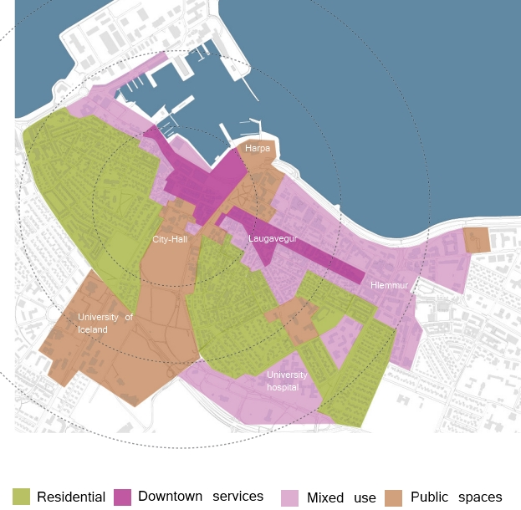

Reykjavik city center – key areas - [Source](http://reykjavik.is/desktopdefault.aspx/tabid-3818/6385_view-2734/)

**Next door to nature**

People in Iceland benefit from a high quality of life; the capital Reykjavik is beautifully situated on the waterfront and surrounded by mountains, wilderness and amazing geological phenomena. Geothermal resources provide green energy for industries, as well as hot water for heating houses and other domestic use. Geothermal water is also used for the country’s signature number of spas and thermal pools, which play an important role in the citizens’ recreational activities and act as a meeting point to discuss the weather and current affairs.

**Small and cozy**

The infrastructure in the capital area is extensive and modern. Distances are short; the average commute only takes 11.6 minutes. The capital area is closely connected to other parts of the country by road, sea, and air. A public bus transport system runs regularly.

**Education**

Reykjavik is a university city with over 16,000 students enrolled in the city’s academic institutes, which are located next to the city center. The nation is generally well educated and over 41% of people living in the capital area hold a university degree. This is comparable to the highest ranking metropolitan areas in the US. Generally, Icelanders are proficient in English. Iceland has excellent infant, primary and secondary schools, and after school daycare centers. There is an [international school](http://www.internationalschool.is/) at elementary level in the capital area. The Hamrahlid high school offers an [International high school diploma](http://www.mh.is/ib) that is taught in English.

**Culture**

Reykjavik is a melting pot for arts and events. It is proud of its impressive cultural scene with literature, music, theater, filmmaking, design, fashion, museums, educational institutions, and scholarly activities regularly available. Reykjavik offers regular festivals such as Food and Fun (February), DesignMarch (March), the Reykjavik Arts Festival (May), and Iceland Airwaves (November). Reykjavik is the UNESCO city of literature based on its invaluable heritage of ancient medieval literature, including *the Sagas*, *the Eddas,* and the *Book of Icelanders*.

**Welfare and Healthcare**

Public and welfare services are highly developed in Iceland, providing multiple services and assistance to its citizens. There is extensive quality healthcare service available in the capital area, with a university Hospital close to Reykjavik city center. Life expectancy is more than 80 years of age in Iceland, ranking it in the top 20 worldwide. Infant mortality rates indicate that Iceland, in the last few years, has the lowest rates in Europe.

**Family friendly society**

The general attitude regarding family life and children is very positive in Iceland, with a good system of legislation in place for the protection of children. When a child is born, the state secures monthly income for each parent for three months, and additional three months that the parents can divide between them. The average birth rate in 2011 was 2.02 children per woman. The state provides thorough and systematic health care for young children, as well as excellent health care for families and individuals. Private Nursery child care is subsidized by the city and Kindergartens / Preschools are run by the city with reasonable fees paid by the parents. The labor market is in general family friendly and many workplaces offer flexible working hours. All full-time employees have the right to 6 weeks’ paid vacation each year. Children in Iceland experience a lot of freedom. Many of them travel to school and sports activities on their own, and children are normally free to go out and play with other kids in the neighborhood.

**Tolerance**

Gender equality and human rights are fundamental in all policymaking for both parliament as well as municipalities. Iceland prides itself on its accomplishments in human rights. Iceland has elected a single mother as president and has a female bishop. From 2009 to 2013 Iceland had an openly gay prime minister. One of the biggest festivals each year is the gay pride parade, where 10% of the population comes together to celebrate diversity. 40% of parliamentarians in Iceland are women which is the [10th highest percentage in the world](http://www.ipu.org/wmn-e/classif.htm). According to the WEF, the [Global Gender Gap](http://www.weforum.org/reports/global-gender-gap-report-2012) in Iceland is the lowest in the world.

**Peaceful and secure environment**

Iceland has been voted as the most peaceful [country in the world](http://www.civitas.org.uk/crime/comments.php). It is the only NATO member which does not have a standing army and its police officers do not carry firearms on regular duty. Crime rates are often difficult to compare between countries because of different legal codes but Iceland has a very [low homicide rate](http://www.civitas.org.uk/crime/crime_stats_oecdjan2012.pdf) with only 0.3 recorded cases per 100,000 population, compared with 5.0 in the USA or 18.1 in Mexico.

**Sport and outdoor activities**

Reykjavik is truly next door to nature, having the waterfront on one side and the Heidmork nature reserve on the other. Inside and outside the city there are many excellent hiking trails and mountains to conquer. The ocean offers excellent opportunities for whale watching, sea angling and water sports. Reykjavik has many golf courses which are open during summer. Municipalities offer excellent indoor and outdoor sports facilities for children and quality training and participation programs are offered in all parts of the city.

# Strategic location

Reykjavik is well placed logistically, not just for Iceland but for the North Atlantic region. Reykjavik has the busiest airport and harbor in the high north Atlantic region of Greenland, Iceland and the Faroe Islands. Iceland also has a unique place on the international timeline, with a time zone that intersects with the workday of both Asia and America.

## Air connections

Reykjavik’s International Airport, Keflavik International Airport is located 45-minutes from the city center and is Iceland's principal international airport, with 35 daily destinations in Europe and North America. During summer this number rises to 65. Flight duration to Europe is 2.5-5 hours, and 5-7 hours to the United States and Canada.

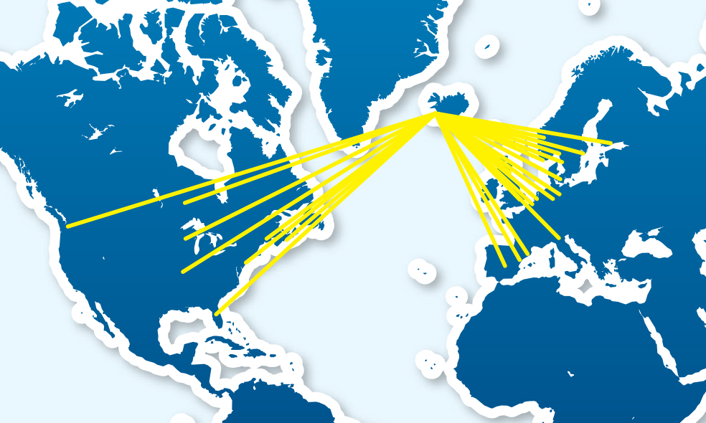

Domestic air services run from Reykjavík Airport, located next to the two universities west of the city center, with regular domestic flights between the largest population areas around the country including Akureyri, Isafjordur, Egilsstadir, and the Vestmannaeyjar Islands. The domestic terminal also services flights to Greenland and the Faroe Islands.

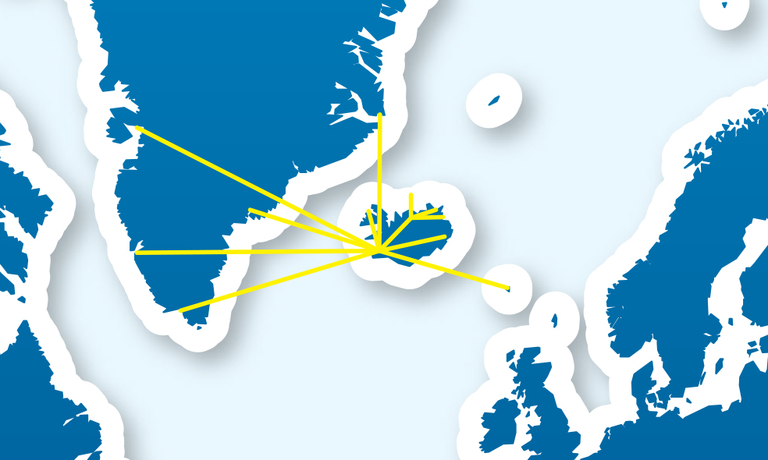

Reykjavik airport North Atlantic route map

## Greenland

The service to Greenland from Reykjavik gives developers looking towards that area a great logistical hub for development. Greenland is believed to be endowed with [oil](http://pubs.usgs.gov/fs/2007/3077/pdf/FS07-3077_508.pdf), [massive deposits of rare earth](http://critical-minerals-2012.geus.dk/presentations/2-3_Karen_Hanghoj_GEUS-20120521.pdf) elements and a landscape that is attractive for tourism. Greenland has limited international flight connections, with only a handful of international flights from Copenhagen to the international airport of Kangerlusaak, often requiring transfers to final destinations. By using Reykjavik as a hub, international companies have regular direct flights to their home base and can fly directly to their development locations in Greenland.

## Sea connections

Icelandic shipping lines operate cargo schedules serving ports in North America, Scandinavia, UK, continental Europe, and the Baltics, and have developed international freight forwarding systems. They also operate bulk charter transportation for specific imports and exports, e.g. industrial raw materials and finished products. Smyril line operates a passenger ferry service between Iceland, the Faroe Islands, and Denmark which goes through Seydisfjordur on the east coast of Iceland. Shipping from Iceland takes 3–4 days to Europe and 7–8 days to North America. Both markets have regular schedules.

The freight ports around Reykjavik are extremely busy all year round with both imports and exports to and from harbors all over Europe and the USA. The two largest freight companies in Iceland, Eimskip and Samskip, both have extensive transport systems connecting northern Europe all the way to Murmansk and America. The companies also specialize in temperature controlled shipping.

Faxaports operates several harbors around Reykjavik. Its operations can be seen in this video:<http://youtu.be/kGh5_eoJFj0>

## Central Arctic shipping route

The shipping route over the North Pole has been opening up in the last few years and traffic has been increasing rapidly although still at very low levels. This could become a new transport connection between the rising economies of East Asia and the established economies of America and Europe. Iceland is located in the middle of the central Arctic shipping route and is well positioned to act as a logistical hub for specific market niches.

As a logistics hub, Iceland lacks the hinterland of larger countries, but it can provide all necessary services and direct flight connections for crew replacements. Several locations in Iceland have been analyzed for a possible transshipment harbor.

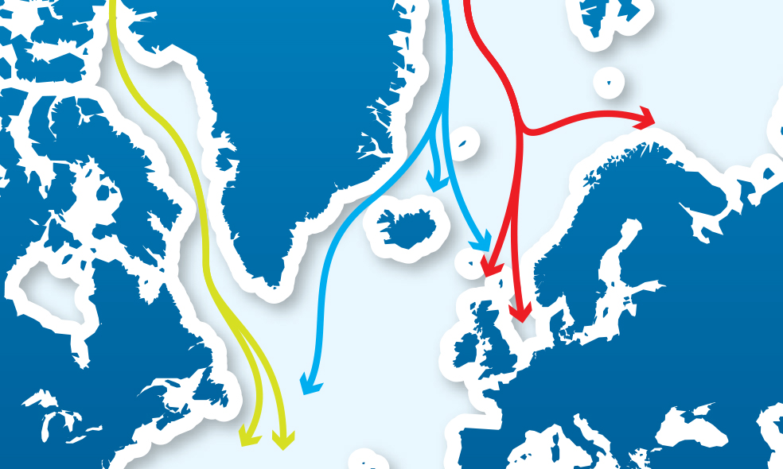

## ICT Connections

Iceland is well connected with the East and West via an efficient Internet service and a thoroughly modern telecommunications network. Iceland has one of the fastest Transatlantic Internet services with Europe and North America via a number of fibre-optic submarine cable systems. The fibre-optic submarine cable systems are Farice, Danice, Greenland Connect and Cantat-3. The Icelandic infrastructure for telecommunications networks and services is highly advanced and all populated regions in the country have access to high-speed fibre-optic cable services. Over 90% of the population has access to the Internet. Iceland ranks among the highest countries in the world on the [ICT development index](http://www.itu.int/ITU-D/ict/publications/idi/material/2012/MIS2012_without_Annex_4.pdf).

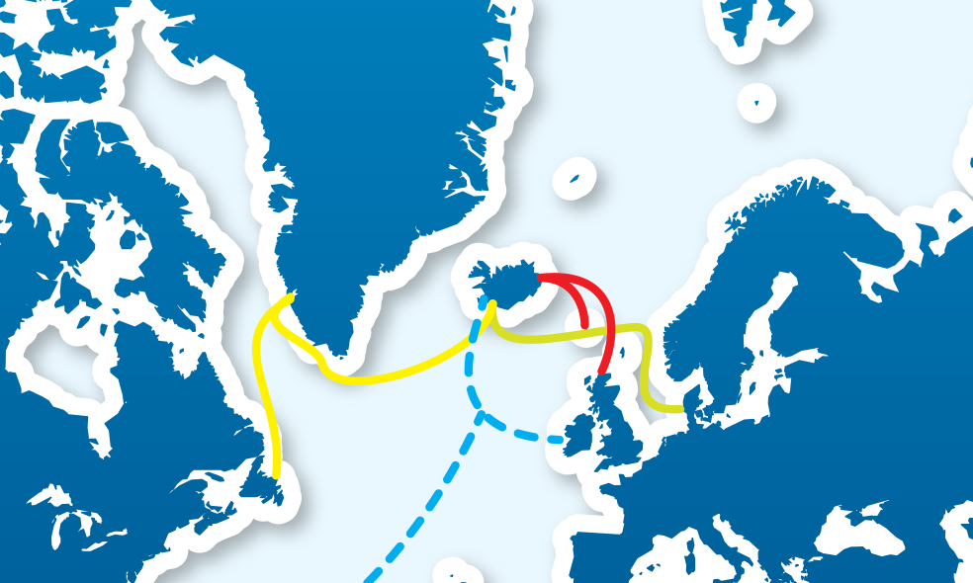

Iceland's data connections – planned for 2014. Source: Invest.is

# Business environment in Iceland and incentives

It is very easy to establish a business in Iceland, which was listed as a top performer on the [World Bank rankings](http://www.doingbusiness.org/data/exploretopics/starting-a-business) of best places to start a business. Iceland minimizes red tape for international business, allowing decisions to be made and implemented quickly, with little time wasted. Reykjavik is a seat of government which means companies can quickly access government agencies and institutions, as they are all located in the city of Reykjavik.

Foreign ownership of business is welcome in Iceland, with few exceptions regarding fishery and energy production. As a member of the 28-nation European Economic Area (all EU states and three of the four EFTA states), Iceland implements the same basic liberal business philosophies as the European Union. All EU commercial legislation and directives take effect in Iceland. Consequently, Iceland makes an ideal springboard for tariff-free access to the major EU market area, as well as a fully competitive location for EU companies to operate. Many foreign companies have set up operations in Iceland, largely around high tech industries and energy technologies.

More information on establishing a business in Iceland can be found [here](http://psc.island.is/en).

**Incentives**

The Icelandic government offers a range of investment incentives for companies including the Technical Development Fund and the Research Fund. Other regional incentives may include fixed ceiling rates on income tax, direct cash grants, and the authorization to lease sites under market value. The Icelandic tax system is relatively simple and effective for corporations.

## Iceland’s workforce

Iceland ranks 5th globally regarding the quality of the educational system, and is the world leader regarding availability of latest technologies in companies and firm-level technology absorption ([WEF](http://www3.weforum.org/docs/WEF_GlobalCompetitivenessReport_2012-13.pdf)). The workforce in Reykjavik is well educated with 41% of the inhabitants achieving a university degree.

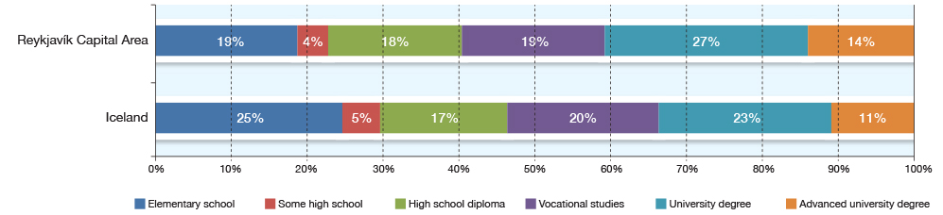

**Education in Iceland and the Reykjavik capital area (Source: Byggdastofnun)**

The workforce in the capital area is quite evenly balanced between production and services. The largest employers are production and commerce. The construction industry and the health industry are the third and fourth industries in terms of number of employees respectively.

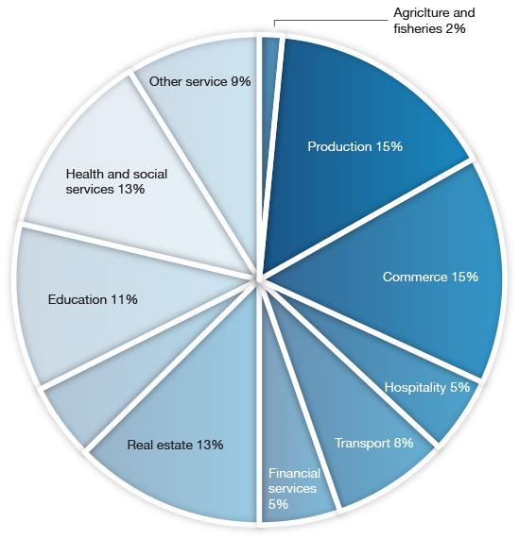

**Picture 4: Employees per industry, Reykjavik capital area 2012 (Source: Statice)**

Due to the relatively small size of the population and the labor market, skilled individual workers can rise rapidly in rank and salary.

According to IMD, Iceland has one of the world’s highest labor participation rates. The labor force is young with 17% between the ages of 16 to 24, while 68% are 25 to 54 years old. Out of a labor force of roughly 180.000 people, the overall participation is 83%. Male participation is 84% and female 78%.

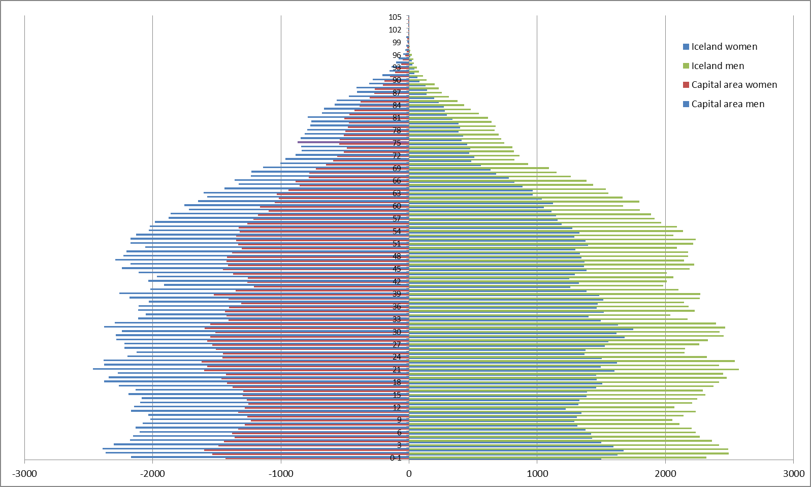

The unemployment rate in Iceland has been very low over the past few decades. When the Icelandic banks collapsed in the fall of 2008 it grew rapidly reaching a peak of 8%. Since then the economy has been re-aligning itself and unemployment rates have dropped to about 5% as of March 2013. Iceland has relatively flexible labor costs with annual labor unit costs and average hours worked similar to the OECD total average.

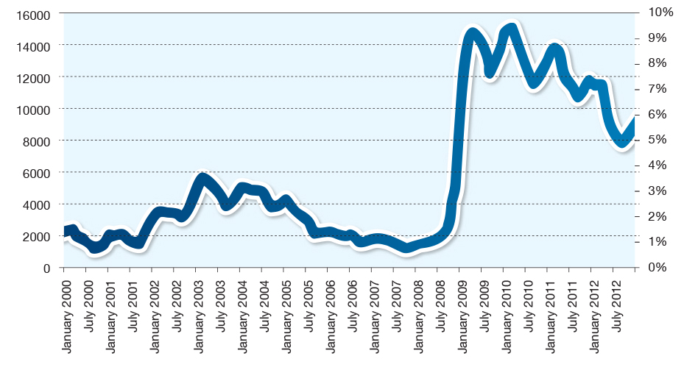

**Picture 5: Unemployment in Iceland from Jan 2000 to Dec 2012. Total and %. Source: Statice**

Citizens of the other Nordic countries—Norway, Denmark, Sweden and Finland—can move to Iceland and find employment without much difficulty. Citizens of other EEA (European Economic Area) countries are also able to move to Iceland without finding employment first (for a period of up to three months, or six months if seeking employment).

## Research / Education

There are seven higher education institutions in Iceland, offering a wide range of university degree programs and specialized courses. Three of the largest universities are located in Reykjavik: the [University of Iceland](http://english.hi.is/), the [University of Reykjavik](http://en.ru.is/) and the [Iceland Academy of the Arts](http://english.lhi.is/). These higher education institutions attract hundreds of foreign students each year and many courses are taught in English. The Icelandic government currently finances two programs for the [United Nations University](http://en.wikipedia.org/wiki/United_Nations_University) that are located in Iceland: the [Geothermal Training Program](http://unugtp.is/), since 1979; and the [Fisheries Training Program](http://www.unuftp.is/), since 1998. The Icelandic universities also attract high quality international students in the fields of geology and languages. The country’s main state research institutions and private research companies are located in Reykjavik.

**Competitiveness**

Iceland is regularily ranked among the most competitive nations in the world. After a severe banking collapse in 2008, Iceland has dropped several places but is still one of the 30 most competitive countries in the world. Here are some summaries of Iceland’s competitiveness from international reports:

**WEF** [**Competitiveness report 2012-2013**](http://www3.weforum.org/docs/WEF_GlobalCompetitivenessReport_2012-13.pdf):

*“Iceland maintains its place at* ***30th position*** *this year. Despite difficulties in recent years, Iceland continues to benefit from a number of clear competitive strengths in moving to a more sustainable economic situation. These include the country’s top-notch educational system at all levels (6th and 13th in the health and primary education and higher education and training pillars, respectively) coupled with an innovative business sector (20th) that is highly adept at adopting new technologies for productivity enhancements (8th). Business activity is further supported by an extremely flexible labor market (12th) and well-developed infrastructure (20th). On the other hand, a weakened macroeconomic environment (123rd) and financial markets (97th) remain areas of concern.”*

**PWC –** [**Northern lights – Nordic capitals analyzed**](https://www.pwc.se/sv_SE/se/offentlig-sektor/assets/northern-lights-2012.pdf)

*“[Reykjavik] ranked second in the performance of its health system and tied with Helsinki for first as the city with least crime … Finally, Reykjavik ranks a strong second in its total tax rate, just 4.3% above that of first-place Copenhagen, and also comes second in ease of starting a business …*

*What all these data tell us, in short, is that when Iceland, just a few years back, reached the summit of an entire range of economic and human-development rankings, it did not do so by accident. The banking crisis was a heavy blow, but the data in our study confirm that Iceland clearly has the economic and social infrastructure in place to return to its place at the top. It cannot happen immediately, but it may happen quicker than most people thought possible just a couple of years ago.”*

More information on the economy of Iceland:

OECD - [Economic Survey of Iceland 2013](http://www.oecd.org/eco/surveys/iceland-2013.htm)

Iceland Central Bank – [Economy of Iceland](http://www.cb.is/library/Skr%C3%A1arsafn---EN/Economy-of-Iceland/2012/EOI_2012.pdf)

Iceland Chamber of Commerce - [Iceland Economic Status report](http://www.vi.is/english/status-report/)

# Energy

Iceland, where 99% of all electricity is renewable, offers visitors a unique window into the future of life and business. [IMD](http://www.invest.is/files/locate-spread-nov-2011.pdf) considers Iceland's hydro and geothermal electricity infrastructure to be the most reliable in the world. Over the past decades, Iceland has significantly reduced its reliance on oil and almost eliminated its use of coal. This has been done through several ground breaking projects such as the Government District Heating Fund, which was created during the 1972 oil crisis and was used to create district heating systems which now heat up the majority of Icelandic homes.

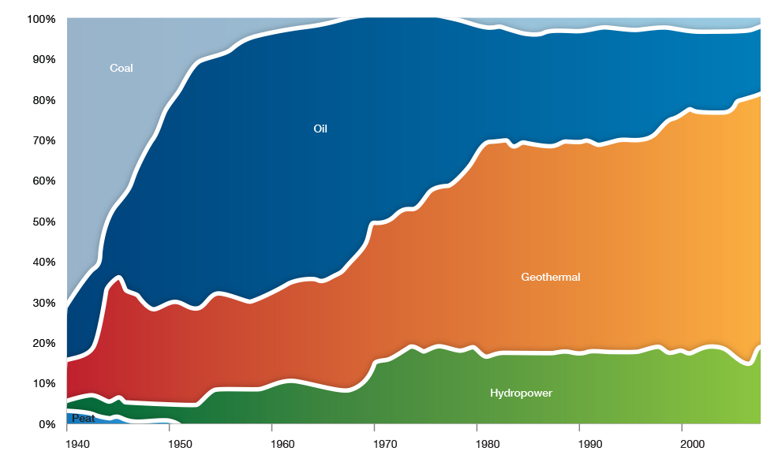

**Picture 6: Net primary energy use in Iceland 1940-2008 (Source: National energy authority)**

Iceland is the first country in the world to base its economy largely on industries fueled by renewable energy and there are still untapped hydroelectric and geothermal possibilities in Iceland. Several educational institutions in Iceland offer university level education in renewable energy, and the University of Iceland is renowned in the global scientific community for its research in this area. Several other institutions and companies, public and private, are conducting extensive research in the field of renewable energy. The IT industry has started using the green energy resources of Iceland to power data centers, and today there are two big data centers in Iceland, Verne Global and Advania, both located in the greater Reykjavik area.

**6. 1 Diversified use of green energy**

Another key strength of Iceland’s green energy is the diversified uses which have been developed. Most geothermal power plants in the world only sell electricity. In Iceland, the geothermal energy is used for heating as well as being utilized to create new industries. [ORF Genetics](http://www.orfgenetics.com/) for example, buys CO2 from a geothermal plant for its greenhouse, which produces barley for biotech. Another example is [Stolt Sea Farm](http://www.stolt-nielsen.com/Stolt-Sea-Farm.aspx) which buys hot seawater from a plant and uses it to farm tropical fish in a controlled environment. This development has just begun and offers great possibilities not just for Iceland but for other areas of the world with access to geothermal resources.

One of the unique factors of green energy in Iceland is the proximity of its production to both the capital city and the international airport. This makes Iceland one of the most accessible development centers focused on geothermal energy.

*“There’s a culture of entrepreneurship, there’s a global mindset, and there’s just a sense of adventure that’s existed here since the Viking times and I can’t think of a better place to start a business or to start the green data center revolution than right here in Iceland”.*

*- Isaac Kato, CFO, Verne Global data center (*[*Source*](http://vimeo.com/14239718)*)*

# Industrial and economic areas

There are several specially designated economic development areas in the greater capital area.

**Grundartangi industrial area**

The Grundartangi port and industrial site is in a non-residential area on the northern shore of Hvalfjordur, 49 km from Reykjavik. The land is green and flat, a former agricultural field and totals 439 hectares, of which some 311 hectares may be developed as building sites. Additionally, 50 hectares can be created by landfills. Already there are two big companies in the area, [Elkem Iceland](http://elkem.is/english/) having a 12.9 hectare site, and Nordural which has a 129 hectare site. Sites have also been allocated to four smaller companies. The remaining area for further development is some 160 hectares.

Associated Icelandic Ports, which is an independently operated company owned by five municipalities, one of which being the City of Reykjavik. Elkem Island (a ferro-silicon producer) and Nordural (a primary aluminium plant) are the largest companies located in the area.

Grundartangi area is very close to the national highway and main road and there is good access to the capital area. Two shipping companies operate scheduled services from Grundartangi and Reykjavik to Europe and North America. Overall pier length at Grundartangi is 580 metres. Maximum water depth now is 14 metres. There is good storage area for containers and raw material.

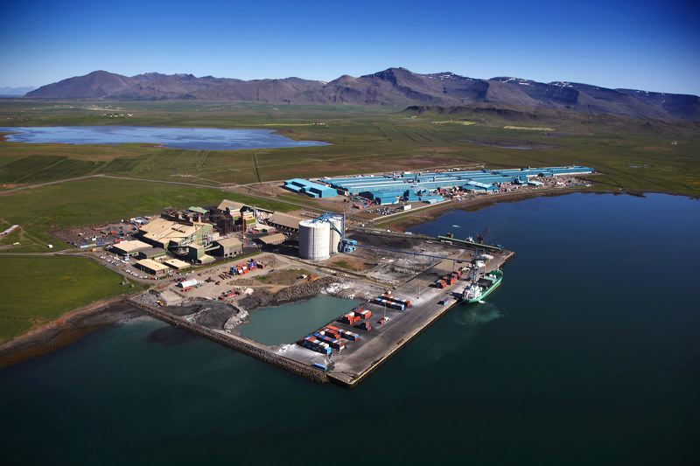

Grundartangi industrial area

# Iceland’s climate and geology: natural risk assessment

Geopyhsicist Dr. Ari Trausti Gudmundsson has written a presentation on the climate and geology of Iceland and the Reykjavik Capital Area. This information is provided to give interested investors a good introduction to important site selection factors.

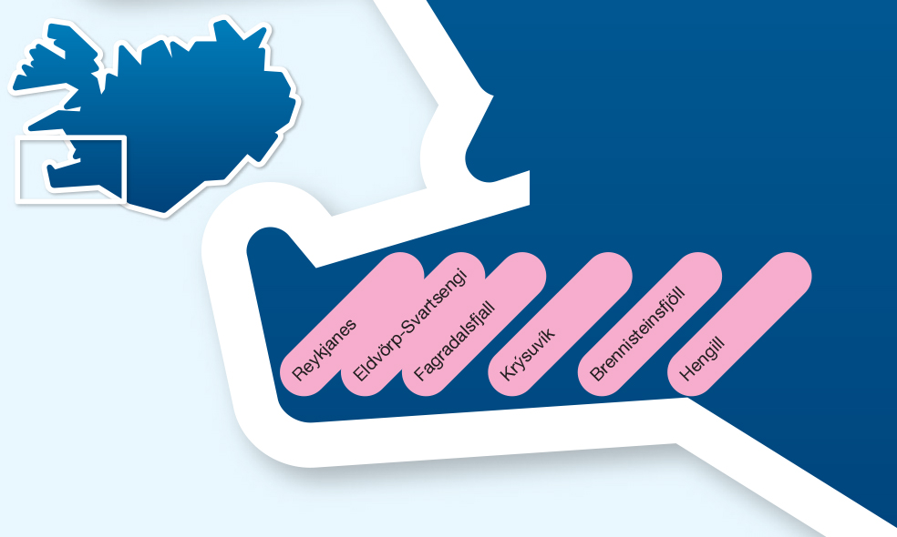

## Iceland’s Climate

As for most oceanic climate areas in the North Atlantic or the North Pacific Ocean, the climate in Iceland has to be coined as relatively mild. The warm Gulf Stream from the Caribbean has a big impact on Iceland’s temperature and weather. This marine current transports warm seawater towards the Arctic Circle, with a branch that almost encircles Iceland. The climate is, however, both windy and rather wet or snowy according to season. Storms are somewhat frequent (wind velocity over 20 m/s), mainly in the period from April to October, a few days each month on the average, in S-Iceland.

Due to a high landscape profile, a prominent föhn-effect prevails in Iceland. During a typical period of föhn, southerly winds bring precipitation to the southern part of the country. Meanwhile, the air dries out in the central highlands and descends – drier and warmer – into the north. A reverse scenario applies to cold, moist air, borne as wind from the north. And the same process is at work for western or eastern winds. On the lee side, temperature may commonly be 4-8 degrees higher than on the windward side, depending on the moisture content of the approaching air.

From early May to early August, Icelanders cherish their long hours of brightness. From mid-June to late July, they see practically no darkness at all. Around June 23, there are about 24 hours of daylight. This annual extended period of daylight shifts Iceland’s weather from cool, often overcast or rainy days to warmer, sunny days with temperatures varying between approximately 8˚C and 27˚C. The average July temperature in the lowlands has been about 12˚C in the south (which has more precipitation) and 10-11˚C in the north (which has somewhat less precipitation). The winter temperature in SW-Iceland commonly ranges from -10°C to +10°C, often hovering around 0°C. The annual precipitation in Reykjavik, much of it rain, is about 800 mm and the recent average annual temperature close 5.7°C, with a maximum over 20°C, from time to time

In general, the Icelandic lowlands have a mild to cool oceanic climate while the highlands are characterized by a somewhat sterner – but still relatively mild – polar climate. At this latitude on the continents, temperatures are generally much colder in the winter and warmer in the summer than they are in Iceland. Winter conditions in Iceland, however, can often turn extreme when high winds or churning blizzards make an air temperature of only -5 to -15°C bite like an Arctic wolf. While it has often rained during Christmas in Reykjavik, it happens much more rarely in the north of Iceland. Global warming has reduced the annual snow precipitation for a number of years now, especially in the south.

## Seismic activity in Iceland

Iceland was gradually formed when the Mid-Atlantic Ridge became positioned close to, and later over, one of the more powerful mantle magma plumes or so-called hot spots in the world. Magma production within the plume, and rising molten rock beneath the otherwise submarine rift ridge, are sufficient to build up an approximately 40 km thick crustal expanse of basalt. The total area is about 200,000 km2, where 103,000 km2 rises above sea level as an island, up to 1,500-2,115 m. The oldest dated rocks above sea level are about 15 million years old, found east and west of the presently active volcanic zones.

The rifting rate (the rate of the divergent tectonic movement) is measured as approximately 2.5 cm per year on average, but in reality the spreading is localised within long volcanic rift zone. It stretched from SW to NE across Iceland. A long period of time usually elapses between rifting events in a particular area. In each rifting episode, the plates "jump" locally apart with associated earthquakes and new fracture formation, or movement on existing faults. The areas hit by the largest earthquakes (magnitude 6-7) are in S-Iceland, 35-100 km east of Reykjavik, and in NE-Iceland, mostly off shore.

In SW-Iceland, the Reykjanesskagi Peninsula, which is included in the volcanic rift zone, has four tectonic fissure swarms where rifting occurs. However, the earthquakes that originate in them hardly exceed 5, except in the Blafjoll area where magnitude 6 may be reached (20-25 km away from the city center).

The Trolladyngja (or Krysuvik) fissure swarm is closest to the Reykjavik urban area and it cuts into the easternmost parts of the city (suburbs of Nordlingaholt and Grafarholt). It is characterized by open cracks and step-like fault lines. Its main center of seismic activity is in an area from Mt. Helgafell (15 km distant) in the northeast to Mt. Fagradalsfjall in the southwest, about 40 km from Reykjavik.

There is no evidence of whether mild nor serious building damage is due to earthquakes in Reykjavik. Building regulations are strict and they incorporate, for example, heavy iron reinforcement of concrete buildings.

## Volcanic activity in Iceland

Within the Iceland rift zones, fracture eruptions, typical of basaltic sea-floor volcanism, are common and large, central volcanoes also occur. In three lateral volcanic zones, however, eruptions tend to be akin to the activity in continental volcanoes. Almost all the different types of volcanic structures can be found in Iceland: crater rows with spatter cones, scoria and pumice craters in offset sections, rows of explosion craters, lava shields related to Hawaiian volcanoes, large mountain ranges with calderas, high cones (stratovolcanoes), volcanic domes and large, circular tephra craters. Submarine eruptions are common, and ice caps cover parts of some volcanic systems. This means that contemporary subglacial eruptions do occur, with ash dispersion and swift melt-water floods.

In the SW-Iceland rift zone (on Reykjanesskagi Peninsula), four closely monitored volcanic systems with their active fissure swarms have been "alive" for thousands of years. Three series of widening of the crust associated with fissure lava eruptions occurred rather recently in the three westernmost systems, including the one closest to the Reykjavik urban area, termed the Trolladyngja (or Krysuvik) Volcanic System. This happened in the late 10th/early 11th century (in the Hengill Volcanic System, east of Reykjavik), in the 12th century (in the Brennisteinsfjoll Volcanic System east of Reykjavik) and finally in 1210-1240. The last series occurred in the sea and on land close to the southern tip of the Reykjanes Peninsula, more than 50 km away from Reykjavik.

Lava flows from the 10th and 11th century events are found 5-10 km away from the outskirts of the city. Lava flows from the 12th century events are somewhat farther to the west and from the 13th century, farther still.

The youngest lava (as a narrow outlet from a larger flow) that managed to flow across the city limits (where there are buildings today) last erupted east of the Blafjoll mountains, some 5,200 years ago. It is found at the Ellidaar River.

It is extremely unlikely that a lava flow would pose a threat to Reykjavik but ash and pumice may fall on the city from a distant volcano, in most cases, however, only as a thin layer.

The bedrock in Reykjavik is chiefly made of lava flows, a few hundred thousand years old, as well as low profile remains of a 2 to 3 million-year-old central volcano.

The geothermal resources within the city limits stem from this ancient geological structure, from the town of Mosfellsbaer plus the Hengill Volcanic System, east of Reykjavik

**Geothermal resources in Iceland**

Geothermal resources are found in most parts of Iceland. The low temperature areas yield hot water from wells and are found in the older bedrock, outside of the volcanic zone. The steam-producing high temperature areas are situated within the active volcanic systems. This applies to the four volcanic systems on the Reykjanesskagi Peninsula. The Nesjavellir and Hellisheidi Power Plants at Hengill supply Reykjavik, and other towns with hot water - they also produce electricity as well. Some 25% of electricity in Iceland is geothermal and 75% from hydropower.

Thus, the energy used for heating and electrical appliances is defined as green or clean energy. This is correct if taken into account that wells in high-temperature areas emit volcanic gasses like carbon dioxide, sulfur dioxide and hydrogen sulfide and that the effluent water from power plants has to be dealt with. Volcanic gasses from the geothermal areas closest to Reykjavik are released into the atmosphere. The air dilution is high so that no hazard exists but the smell can be unpleasant. Much of the effluent water is pumped back into the geothermal reservoir and experiments made in order to dispose of carbon dioxide and hydrogen sulfide by along with the effluent water. Some of the effluent water at the Hellisheidi Power Plant will maybe be used for large-scale geothermal greenhouse farming.

## Rivers in Reykjavik and possible flooding

There are no rivers to speak of within the Reykjavik city limits, apart from the small Ellidaar, a well-known salmon river

The recorded sea level rise of 3-4 millimetres per year is caused by global warming and by the volcanic activity that causes heavy rocks to pile up in the long term, which again causes the crust to sink in. Heavy storms, especially SW-storms, have caused some minor flooding at the coastline. To counteract, rock walls have been built along much of the coast.

Serious short-term sea flooding hazards are not at hand in Reykjavik and its vicinity. However, the rising sea level has to be gradually encountered by various preventive measures after some decades, if the current global climate change continues.

# Key Industry Clusters

Reykjavik is not only inspiring for its proximity to pristine nature, but also for its world-renowned approach to sustainability, its vibrant creativity, and industry that flourishes here. With a well-educated and highly skilled workforce, affordable green energy, and tremendous investment and business accelerator opportunities the city is ripe with opportunity.

Reykjavik is quickly gaining a reputation as a Startup City, an incubator for burgeoning and globally-facing entrepreneurial ventures. Reykjavik is a world leader in geothermal and ocean related industries. Other industry clusters in the city are the biotech, medical equipment, tourism, IT and the creative industries. In all of these industries there is a bourgeoning startup community.

## The Reykjavik Startup Scene

With a well-educated and highly skilled workforce, affordable green energy, and tremendous investment and business accelerator opportunities, Reykjavik is quickly gaining a reputation as a Startup City, an incubator for burgeoning and globally facing entrepreneurial ventures.

The IT startup scene is located mostly in the downtown area. Iceland offers startups tremendous opportunities offering grants, affordable green energy, and centrally located downtown office space near a good selection of eateries, cafés, and bars. Reykjavik has a significant amount of IT talent with an entrepreneurial mindset in a close knit creative society where most companies are positioned for globally facing business.

Iceland has a new emerging industry which is capitalizing on the inexpensive green energy to power its solutions which are hosted in Iceland's two most significant global data centers, [Advania](http://www.advania.com/) and [Verne Global](http://www.verneglobal.com).

The Icelandic startup ecosystem has a number of events such as Startup weekends, Business plan competitions, [Seed forum](http://www.seedforum.is/), and the [Startup Iceland](http://startupiceland.com/) Entrepreneurial conference. Startups are further supported by innovation support companies such as [Innovation Iceland](http://nmi.is/english), [Klak Innovit entrepreneurship center](http://www.klak.is/english/), and the [Startup Reykjavik](http://www.startupreykjavik.com/) accelerator program.

Several startups have been acquired by large international companies. [DeCODE Genetics](http://www.decode.com/), a world leader in genetic research was purchased by the American biopharmaceutical company Amgen in 2012, [Lazytown](http://lazytown.com/) which was acquired by [Turner Broadcasting](http://www.turner.com/) for $21 million. Or Clara, a software company which was developed by students at the University of Iceland and bought by [Jive Software](http://www.jivesoftware.com/) for €6,8 million in early 2013.

*“For a company like ours it makes perfect sense to base our development team in Reykjavik rather than London. Office space in London can cost more than fifty times what it costs in Reykjavik per square meter, the talent pool in Reykjavik is rich and the work ethic is strong.“*  
– Geir Freysson, CEO, Transmit ([Source](http://www.geirfreysson.com/2012/01/an-icelandic-startup-using-london%E2%80%99s-tech-city-as-a-launchpad-%E2%80%93-my-talk-at-the-british-embassy-in-brussels/))

## Iceland Ocean Cluster

Iceland has two leading companies in the world in the marketing and distribution of fish, two leading players in food shipping in the North Atlantic and over 70 technology firms, many of which have become global providers of various products for the food, aquaculture, and fishing industry in the world.

Seafood export represents around 40% of Iceland’s total product export compared to just 5% in Norway. The total export value was $2,2 Billion 2012. The seafood cluster has a 10% direct contribution to GDP which is amongst the highest in the OECD. If you add the indirect effects the contribution scales to 26% of GDP or $3,3 Billion.

On the basis of high value seafood, Iceland has created several world class technology companies serving the seafood sector which have diversified into other areas. Among these companies are [Marel](http://www.marel.com/), [Promens](http://www.promens.com/), [3X Technology](http://www.3x.is/), [Trackwell](http://www.trackwell.com/), [Valka](http://valka.is/) and [Marorka](http://www.marorka.com/). By far the largest company in this group is [Marel](http://www.marel.com/), the leading provider of technology for the global food processing industry.

In 2010, Iceland was No.1 in the OECD in seafood research. The major universities work with the seafood sector in increasing productivity. The Icelandic fishing fleet is one of the most advanced in the world and is a lead user for many industry innovations. More information on the Iceland Ocean Cluster can be found [here](http://www.sjavarklasinn.is/en).

## Iceland Geothermal Cluster

Iceland is uniquely situated in terms of access to a quality resource. The high percentage of geothermal energy as proportion of Iceland's total primary energy (85%) consumption is unique in the world. Most of the development of geothermal utilization in Iceland has occurred for the last one hundred years or so, especially in the latter half of the 20th century. Iceland is a strong player in the global geothermal market, enjoying the benefits of a powerful geothermal cluster. The cluster’s strength consists of a developed system for using geothermal energy in multiple ways, experienced specialists, and a strong international reputation and network.

In 2010 Iceland’s total economic benefit from geothermal was calculated to be between [$480-830 million](http://www.or.is/media/PDF/IGC_2013_Bjarni_Bjarnason.pdf) or 4-6% of GDP. This value is derived from space heating benefits, industry benefits, resource leasing, and social impact. [Reykjavik Energy](http://www.or.is/English/) is probably the largest geothermal company in the world based on power creation.

## IT Cluster

The IT cluster of Iceland has a turnover of 450 million USD and around 2,100 employees and growing. The key markets for Icelandic IT are UK, Scandinavia and North America. The current key sectors are gaming, web hosting, data storage and seafood related services. Iceland has a very tech savvy population, with very good access to broadband and good education. This makes Iceland an attractive place to build and test new technology before moving into larger markets.

The sector’s fastest-growing segment has been video game sales, whose turnover jumped six-fold in 2005–2009. The same trend can be observed overseas, in line with increased computer and Internet use. Iceland’s video game turnover is nearly entirely export-driven. Among exciting companies in the Icelandic IT cluster are gaming companies such as [CCP](http://www.ccpgames.com/) and [Plain Vanilla](http://www.plainvanilla.is/). In services, [Advania](http://www.advania.com/) is one of the largest Scandinavian IT service companies and [GreenQloud](http://greenqloud.com/) is gaining traction for web hosting and data storage in the National Research and Education Networks (NRENS). Iceland is a leader in the personal finance space in [Meniga](http://www.meniga.is) and [OZ.com](http://www.oz.com), and has solutions revolutionizing the delivery of HD video content.

## Health cluster

Iceland has developed specialized knowledge in several fields of health throughout the past few years. This has happened through the combination of well-educated workforce with an international outlook, both in Europe and the US. Iceland’s health cluster is strongest in the fields of pharmaceuticals and medical equipment where it has world class companies.

**Medical products**

Iceland’s medical products industry has been growing rapidly with many interesting companies being established. The best known companies are [Actavis](http://www.actavis.is) pharmaceuticals, [Alvogen](http://www.alvogen.is) pharmaceuticals, and [Össur](http://www.ossur.com/corporate) prosthetics—all top companies worldwide in their fields. Several foreign companies have research divisions in Iceland, such as Amgen which has a genetics research department in the Vatnsmyri science park.

**Health tourism**

The health cluster also includes companies focusing on public health such as [Lazytown](http://www.lazytown.com), which produces entertainment for children focused on healthy living. Iceland is also a well-known health tourism destination with one of the world’s best Spas, the [Blue Lagoon](http://www.bluelagoon.is).

## Creative cluster

The creative cluster consists of various enterprises, entrepreneurs and institutions in architecture, design, literature, arts, music, fashion, and film. The creative industries in Iceland have flourished and Reykjavik has become a melting pot of exciting new creative enterprises, with individuals seeking to expand their businesses overseas.

The creative cluster of the Reykjavik Capital area is one of the the largest business clusters in Iceland and often intersects with other clusters. Iceland’s creative industries generated a turnover of ISK 189 billion in 2009, accounting for 6.36% of the economy’s total VAT taxable turnover. Full-time equivalent jobs in the creative industries are almost 10,000. Export revenues for this sector in 2009 were about ISK 24 billion, or approximately 3% of Iceland’s total exports. Despite the general downturn in other sectors, turnover in the creative industries has remained fairly constant, with the number of full-time equivalent jobs rising.

The Icelandic creative cluster has two strong sub-clusters in design and film.

**The Icelandic Film Industry**

Iceland has become popular as a filming location in the last few years. Iceland has built a small but highly flexible and creative filming industry which has experience working with Hollywood’s top talent. The [Film in Iceland](http://www.filminiceland.com) agency is responsible for attracting foreign movies to Iceland.

*“Filming in Iceland was a spectacular experience! It is one of the most wonderful places I’ve ever been. The Icelandic crew was amazingly efficient and made the job a real pleasure.”*

-Ridley Scott, Prometheus, 2012

Building on these large foreign projects and on the ongoing local development, Iceland has developed its own film industry. The largest company in the film industry is Turner Broadcasting, which owns [Lazytown](http://lazytown.com/), a children’s TV show viewed by children in 170 countries. Other production companies include [Saga Film](http://sagafilm.is/) which is one of the three major service companies to foreign film production crews along with [True North](http://www.truenorth.is) and [Pegasus](http://www.pegasus.is).

There are a few visual graphic companies in Iceland such as Framestore, which creates after effects for movies and computer games. Caoz has produced a few CGI movies including the full length feature film Thor – Legends of Valhalla. Another CGI company is GunHill which is also working on a full length feature CGI film.

## Tourism cluster

Iceland has unique landscapes and sites which draw tourists to the country. Lonely Planet has named Iceland and Reykjavik as its [top destinations for 2012](http://www.lonelyplanet.com/europe/travel-tips-and-articles/76855) and National Geographic has named Iceland’s Blue Lagoon Spa as one of the [wonders of the world](http://www.bluelagoon.com/about-us/news-list/blue-lagoon-is-one-of-the-wonders-of-the-world/4/).

Tourism today is one of the fastest growing sectors in Iceland with passenger traffic coming through Keflavik International Airport growing by 12.7% between 2011 and 2012. The biggest visiting nationalities coming to Iceland are the US, UK, Germany, France, and the Scandinavian countries. The biggest increase in percentages came from Russia rising by 82% -- Landsbanki research data shows that tourists from Russia are also the heaviest spenders.

Tourism represents 6.6% of GDP in Iceland and contributes to 19% of the export income. Foreign currency earnings from foreign tourists is growing with the growth of incoming tourists, equalling around $500 million in 2012. Reykjavik offers investors several interesting investment possibilities in tourism. For more information contact the department of economic development at invest(at)reykjavik.is.

**Cases:**

**Clara**

Early in 2013, Reykjavik startup Clara exited with a $6.8 million acquisition by Silicon Valley company Jive Software. Clara was founded in 2008 by students at the University of Iceland in Reykjavik. They participated in the Startup ecosystem from day one participating in the Gullegg (golden egg) business plan competition organized by the Innovit centre for innovation and entrepreneurship winning second place.

While building up their company they inhabited several incubators in Reykjavik: Innovit, the Ideahouse (operated between 2008 and 2011), Innovation Iceland incubator untill landing in their own offices in downtown Reykjavik on the Laugarvegur shopping street. Two venture funds based in Iceland, NSA Ventures and Auro investment partners, invested in the company. Auro in 2010 and NSA in april 2012.

After a couple of years, the company decided that it needed presence closer to the market so they shipped CEO Gunnar Holmsteinn to San Francisco where he opened a second office. After a few years of hard work in Silicon Valley the company was acquired.

This model, using talent in Iceland to create a product and selling in Silicone Valley has worked out for Clara and hopefully is a proof of concept for the Icelandic startup ecosystem. In a great talk at the Startup Iceland conference last year, Gunnar talked about the differences between entreprise sales in Iceland and the US where he and his friends sold their product in Iceland within days, but in the states it took him months to get close to a sale. Clara creates software which helps companies analyze what their user community is saying about them on the web. Their key product, [Resonata](http://www.resonata.com/),  became a key part of Jive’s service portfolio.

Paolo Alto based Jive Software ([JIVE](http://www.globenewswire.com/newsroom/ctr?d=10030728&l=14&a=JIVE&u=http%3A%2F%2Ffinance.yahoo.com%2Fq%3Fs%3Djive)) is a leader in social business.  Their cloud-based platform connects employees, customers and partners and is a proven system, focused on value use cases.  Their revenues in Q1 of 2013 were $33.9 million growing 34% from Q1 2013. The biggest owners of Jive include VC’s [Kleiner Perkins Caufield & Byers](http://www.kpcb.com/) and [Sequoia Capital](http://www.sequoiacap.com/).

The biggest owners of Clara were CEO Gunnar Holmsteinn (16%), Co-founder Jon Edvald (14%), Auro investment partners (34%) and [NSA Ventures](http://www.nsaventures.is/) (18%).